THEORY QUESTIONS

SECTION I

THE ENVIRONMENT
1.
a)

Study the map of Ghana shown on below and identify the administrative regions marked I, II, III, IV, V.
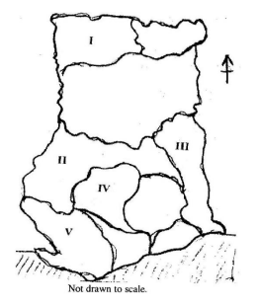
b)

Outline five ways in which mountains and highlands are important.

2.
a)

List four features of a slum.
b)

Enumerate four measures that can be taken to prevent slums in the urban towns of Ghana.

SECTION II

GOVERNMANCE, POLITICS AND STABILITY
3.
a)

Match the political events listed below with their corresponding activities in the table that follows
- The Poll Tax Ordinance of 1852
- The Bond of 1844
- The 'Sagrenti' war of 1874
- The 1948 riots
- The YaaAsantewa war of 1901
Political Activity |  | Event
I | An agreement signed between the British government and some chiefs of the Gold Coast
II | The war fought by the British soldiers under their leader Sir Garnet Wolsley and the people of Ashanti
III | The disturbances that occurred in the Gold Coast after the shooting of the ex-service men by the British soldiers
IV | The introduction of a law to collect taxes from the people of the Gold Coast
b)

Outline four attitudes and values needed to prevent conflict in the community.

4.
a)

List any four ethnic groups in Ghana.
b)

Explain any four ways of sustaining unity among the different ethnic groups in Ghana.

SECTION III

SOCIAL AND ECONOMIC DEVELOPMENT
5.
Explain five measures that can be adopted to improve the quality of life in the rural areas.

6.
a)

What is the difference between education and training?
b)

Enumerate four advantages of using modern technology in the production of goods and services.

